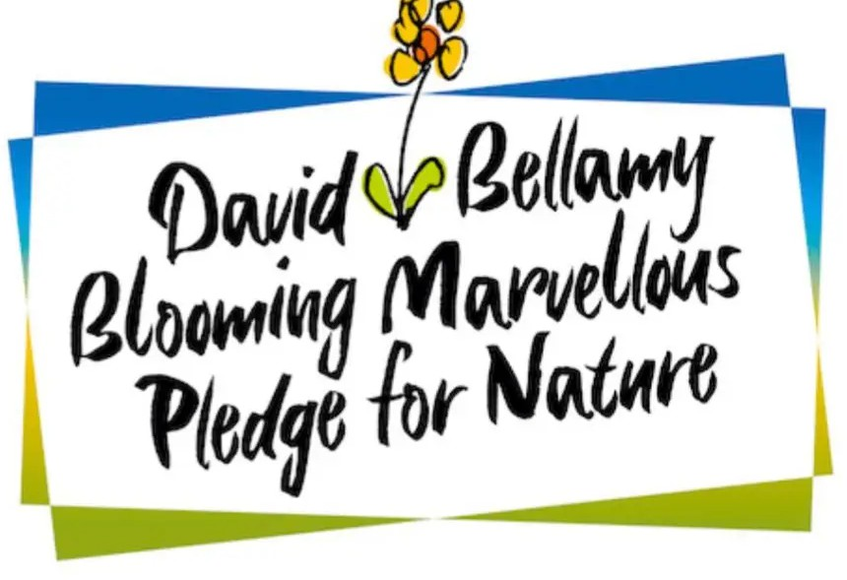

Wildlife Plan 2025

Use the ﬁve points of the Pledge to inform and direct your environmental work over the next year and beyond.

Select your wildlife challenge.

Draw up an action plan and set your team to work.

|  |
| --- |
| Park name: |
|  |
| What challenge pledge are you taking on?  e.g. pollinator patch |
| What is your overall aim?  *Please provide a brief summary,* e.g. to create a wildﬂower meadow |

Now use the project plan template on the next page to detail what you are going to do. Please include as much detail as possible to help us see if you've got enough planned to win the challenge.

|  |
| --- |
| Your Plan |

Step 1:

e.g. identify the area for the meadow

Target Date

Step 2:

e.g. research and engage with local horticultural societies to identify correct species to grow and how to manage meadow

Target Date

Step 3:

e.g. purchase seed, prepare soil and sow the meadow

Target Date

Step 4:

e.g. maintain and evaluate meadow, plan mowing regime

Target Date

Step 5:

e.g. document and share with guests through onsite signage and social media

Target Date